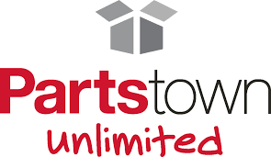

About Parts Town Unlimited
Parts Town Unlimited is the parent company of over 49 unique brands worldwide which collectively serve as a global leader in the high-tech distribution of genuine original equipment manufacturer (OEM) parts for foodservice equipment, residential appliances, HVAC equipment and consumer electronics, as well as related products and services. Parts Town Unlimited is constantly working to create user-friendly parts identification tools, expand its high-tech distribution capabilities and foster forward-thinking innovations.

Guided by its core values of Safety, Integrity, Community, Passion, Courage, and Innovation, Parts Town Unlimited delivers infinite possibilities, unlimited potential, and boundless innovation with a focus on people and long-term partnerships. The company was recently recognized by The Inc. 5000 as one of the fastest-growing companies in the U.S. for the 17th consecutive year.

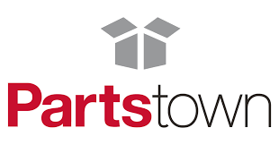

About Parts Town
Parts Town is the leading, technology innovation-driven distributor of genuine OEM (original equipment manufacturer) foodservice, residential appliance and HVAC equipment repair parts. When there’s a hiccup with any piece of equipment, Parts Town is ready to jump in and help with the most in-stock parts on the planet, innovative technology, and an unmatched customer experience. Customized solutions benefit equipment service technicians of all kinds, as well as chain and independent restaurants, schools, health care facilities and hospitality providers.

By partnering with the top manufacturers of foodservice, residential appliance and HVAC replacement parts, Parts Town improves the supply chain, increases sales of genuine OEM parts and keeps every customer’s business running like clockwork. Parts Town also partners with equipment and supplies dealers of all sizes to offer a one-stop-shop through its Parts Town marketplace.

For more information, visit https://www.partstown.com/.

####

Parts Town Media Contact
Jessica Harris
jharris@partstown.com

